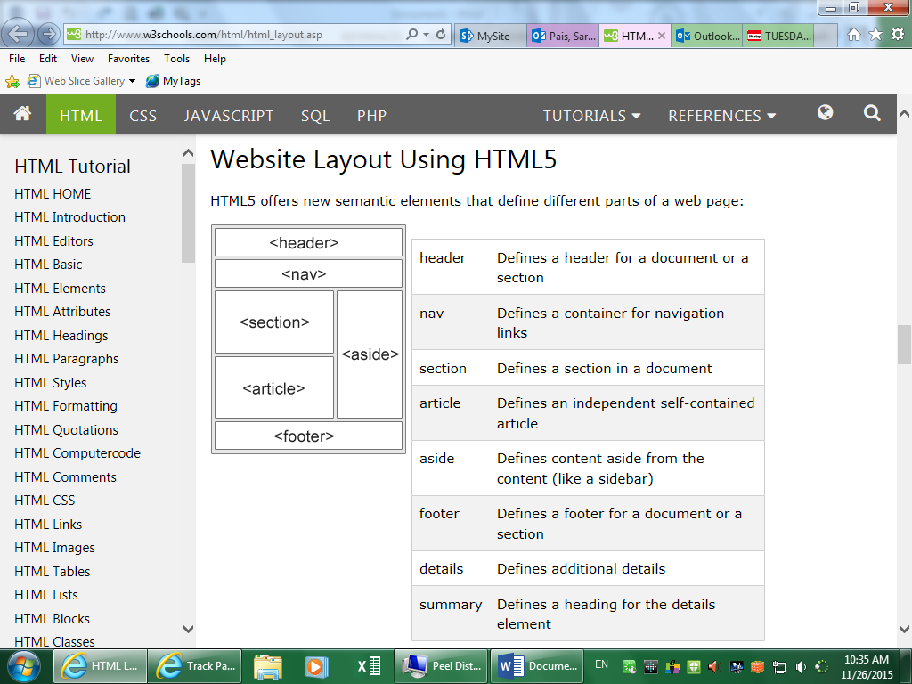

Taken from w3schools.com

|  |  |
| --- | --- |
|  |  |

For a list of CSS properties: www.w3schools.com/cssref/